Monday 8th February – Reception – Please check Tapestry regularly as teachers will upload videos to support with Maths, Phonics and other EYFS skills.
Have an active start to the day – A-Z
Using a pen and paper go through the alphabet and place A-Z on different sheets of paper. The aim of the game is to find the letters around your home once the letter has been called. Happy alphabet hunting! To make it trickier, have a time limit involved.

Daily Read, Write, Inc lessons
https://www.youtube.com/channel/UCo7fbLgY2oA_cFCIg9GdxtQ - Please head to the Ruth Miskin YouTube page to access daily Read, Write Inc lessons that are taught by a RWI expert.
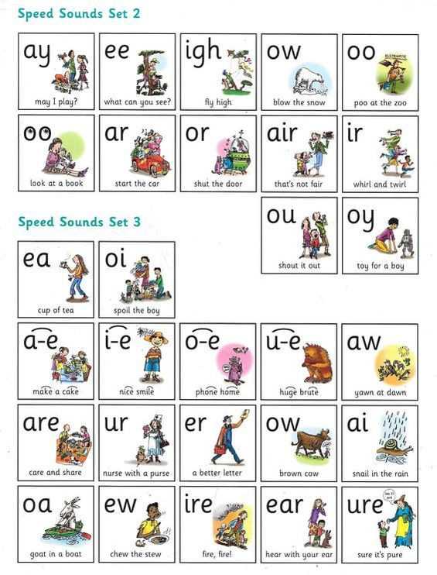
If you are unsure on how to pronounce the sounds – this video is very useful for parents https://www.youtube.com/watch?v=TkXcabDUg7Q
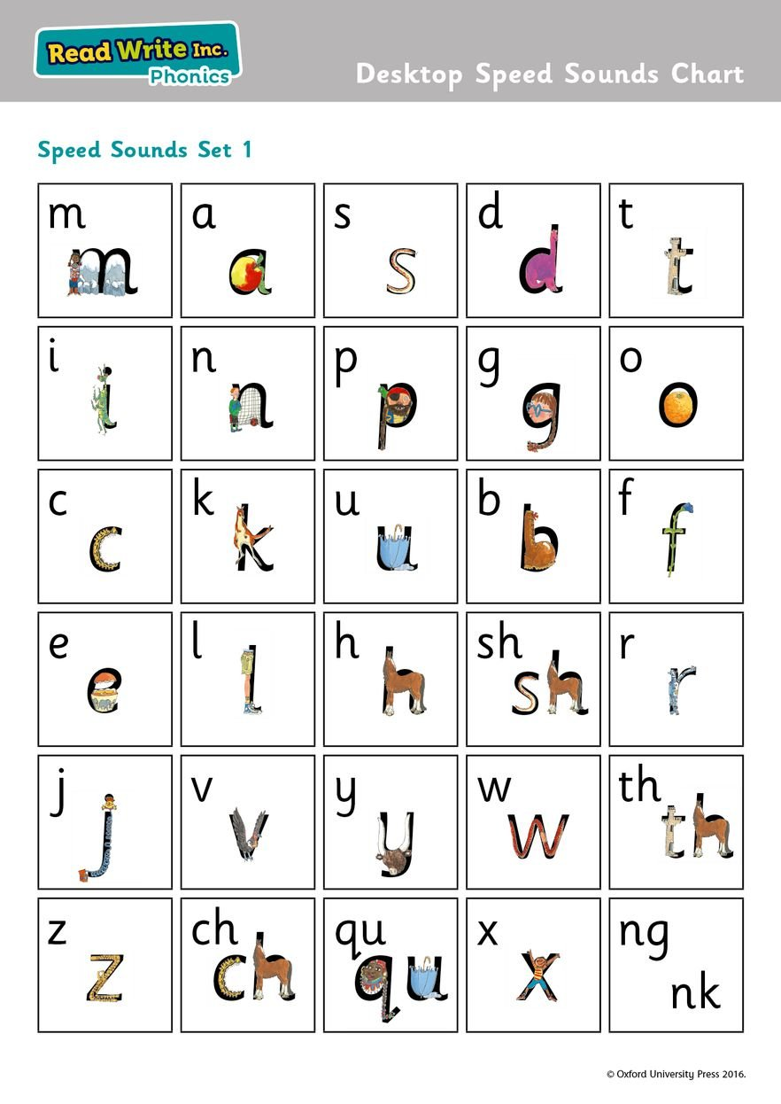

Phonics Activity
Use the word document attached to do a red word colouring activity. You might like to go through some red words with your children beforehand, please remind them that you cannot sound out a red word.

Maths (Weight)
Talk to the children about ‘heavy’ and ‘light’. Discuss the meanings of these words. You might like to demonstrate by mocking your arms up as a balancing bucket. If something is heavy your arms would be nearer to the ground, if something is light – higher to the sky.
On two pieces of paper, write the words ‘heavy’ and ‘light’. Then have a look around the house and find 10 objects. When you have found your objects, gather them up together and talk about their weight 2 by 2. For now, children can estimate and get a feel for the object by placing it in their hands, which ones is light? Which one is heavy?

Literacy – Reading/Understanding
Our question around the Polar Regions is this week is about people. We will find out more about Inuits later on in the week. Explain to the children that most Inuits shelter in igloos and today we are going to be writing about igloos. Below is a short video that demonstrates how an igloo is built.
https://www.youtube.com/watch?v=ky57HCQPSNk
So, we are going to be looking at non-fiction today. Explain non-fiction to the children and in particular the word ‘fact’. First of all, use a book or the internet to see if your child can find out a fact about an igloo. Any fact you like! We would love to hear about your fact. Next, after you’ve researched carefully see if you can sort these sentences into a fact pile… careful though, some sentences might be made up! You can help your child read the sentences.

Please email the admin email if you need any help and Mrs Power or Mrs Marshall will forward on emails to us. We will continue to set daily activities to have a go with at home. Stay safe everyone, we miss you already! Please pop all activities you do onto Tapestry where we can have a look, comment and guide you on next steps and challenges. Miss Wilkinson and Mrs Simpson

