Friday 5th March – Reception – Please check Tapestry regularly as teachers will upload videos to support with Maths, Phonics and other EYFS skills.
Have an active start to the day – have a go at this Cosmic Yoga – safari adventure
https://www.youtube.com/watch?v=kRw6sGwN4U4

Daily Read, Write, Inc lessons
https://www.youtube.com/channel/UCo7fbLgY2oA_cFCIg9GdxtQ - Please head to the Ruth Miskin YouTube page to access daily Read, Write Inc lessons that are taught by a RWI expert.
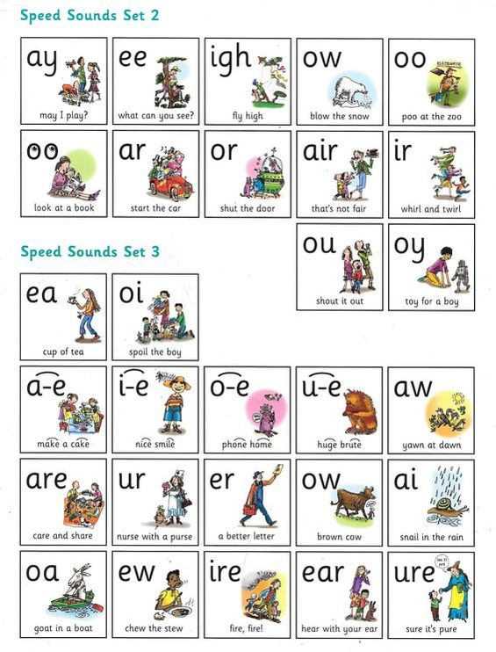
If you are unsure on how to pronounce the sounds – this video is very useful for parents https://www.youtube.com/watch?v=TkXcabDUg7Q
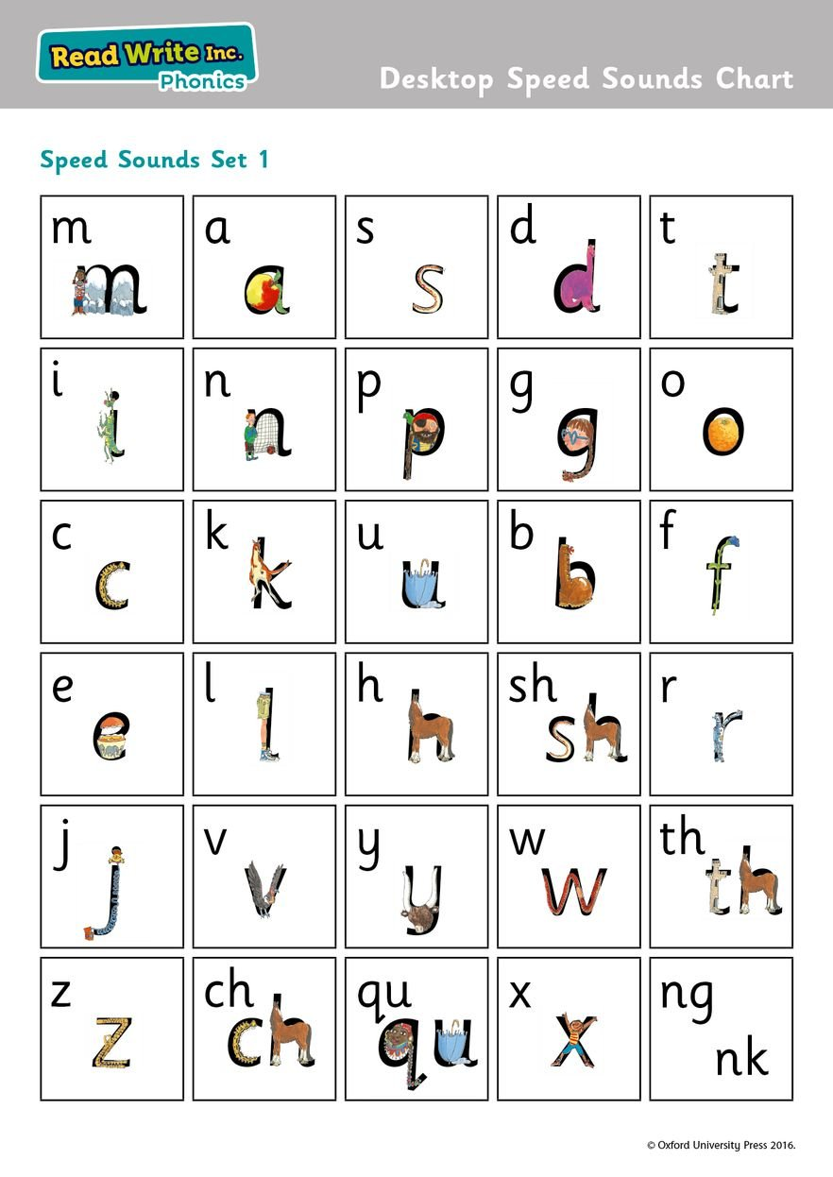

Phonics Activity
Complete some more activities from the phonics booklet from yesterday.

Maths (Time)
Have a look at this online teaching clock, discuss the different hands on the clock and demonstrate to your child how the hands move by adding hours and minutes on to the clock. Begin with teaching o’clock times and then allow your child to play with pressing the buttons and changing the time. Discuss what time it is each time your child changes it.
https://www.topmarks.co.uk/time/teaching-clock

Fun Friday!
Well done for working so hard at home! You have all been amazing and worked so hard! We cannot wait to see you all in school on Monday. Spend this afternoon having fun as a reward for super home learning. All the grown ups are very proud of you!

Please email the admin email if you need any help and Mrs Power or Mrs Marshall will forward on emails to us. We will continue to set daily activities to have a go with at home. Stay safe everyone, we miss you already! Please pop all activities you do onto Tapestry where we can have a look, comment and guide you on next steps and challenges. Miss Wilkinson and Mrs Simpson

