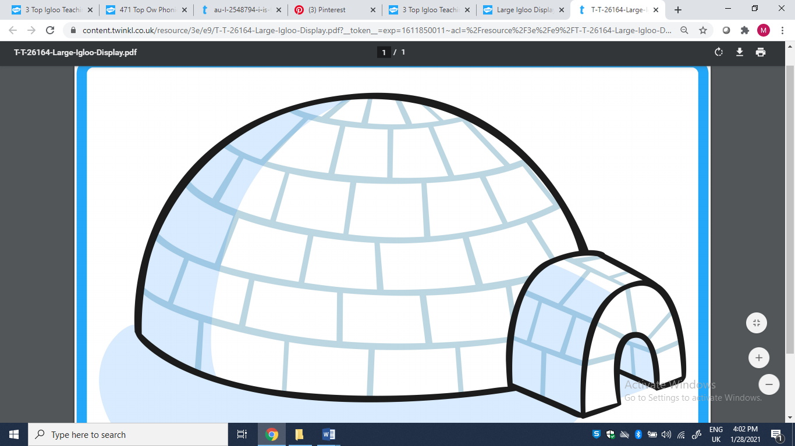

Look at my word igloo! You will be able to use Fred fingers to sound out some words, but some

are red words… and you can’t Fred a red! Use red crayon to colour in all the blocks of red word ice. Use blue crayon to colour in all the blocks you can sound out.

boot

fun

melt

my

big

blow

snow

said

go

no

I

the

to