Fertiliser(for each veg)

£2.00 for 5m2 which equals 40p /m2

Duck feed - £3.00/m2

Grass seed (horse,cow&sheep)-

2.50/m2

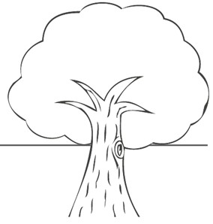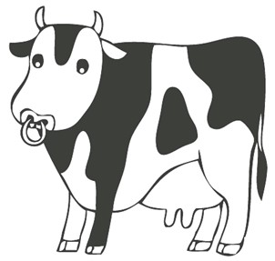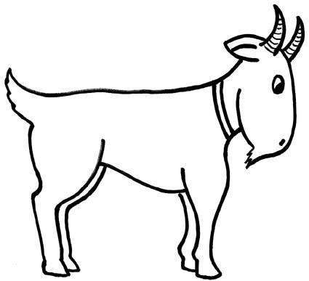

Farm Yard Constraints

You must grow

at least three

types of

vegetable

You only have

150

lengths of fencing

to use.1m costs £1.50

You must

include the

farm buildings.

At least a half

of your chickens

have to be free

range to stop

animal rights

protesters.

Only up to half of

your animals are

allowed to be used

for meat so that

they can

repopulate.

If you have goats and

at least two other

animals you will add an

extra £100 to your

total value from school

visits.

Fertiliser(for each veg) - £2.00 /5m2

Duck feed - £3.00/m2

Grass seed (horse,cow&sheep)-2.50/m2

ed